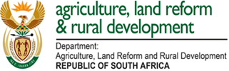

Directorate Food Safety and Quality Assurance
Private Bag X343, PRETORIA, 0001 ●Tel: (012) 319-6051
Web address: www.Dalrrd.gov.za
Enquiries: Mr Willy Motlana Madiba

Chemical Substance | SA | EU | Codex
Alpha – cypermethrin | No MRL | No MRL | No MRL
Carfentrazone-ethyl | No MRL | 0.02 | No MRL
Cyanamide | 0.05 | 0.01 | No MRL
Cyprodinil | 2 | 0,02 | No MRL
Forchlorfenuron | No MRL | 0.01 | No MRL
Fenthion | 1 | 0,01 | No MRL
Glufosinate-ammonium | No MRL | 0.6 | No MRL
Glyphosate | No MRL | No MRL | No MRL
Fludioxonil | 15 | 15 | 15
Iprodione | 5 | 5 | 5
Malathion | 0,01 | 0,01 | 0,01
Metalaxyl M/Mefenoxam | 0,1 | 0,02 | No MRL
Spinosad | No MRL | 0.05 | No MRL

